**Strongly typed language**

We call **C/C++** and **Java** are **strongly typed languages** and **JavaScript** and **PERL** are **loosely typed languages.** What does it mean?

Either in C or Java, when a variable is declared, it must be informed to the compiler what data type the variable stores like integer, float, double or string etc. Observe the following variable declaration in Java.

***int marks = 20.***

***String str = "way2java.com";***

***boolean raining = true;***

The variable must be declared along with the data type. Similarly, an array object must be instantiated with the size. This is a feature of strongly typed languages.

Just reverse with **loosely typed language**s. Observe the variable declaration in JavaScript, an object-based language.

***var marks = 20.***

***var str = "way2java.com";***

***var raining = true;***

Say in Java language:

***int cost = 10;***

***int cost = 20;***

It is compilation error as two times cost is initialized. You must declare only ones and can be reassigned number of times as follows.

***int cost = 10;***

***cost = 20;***

Same thing in JavaScript or PERL is not error. Observe the code.

***var cost = 10;***

***var cost = 20;***

The earlier cost value is overridden with 20, but not error; earlier value is lost. This is a very dangerous situation which leads problems. If an article costs Rs.10 and the programmer declared correctly earlier. In the later part of the code, he forgot that he declared and redeclares with a different value (which may be wrong). For this reason, the object-based languages like JavaScript, PERL and Ruby etc. have limited scope in programming and are not used as full-fledged languages to develop software like banking, insurance etc.

A strongly typed language compiler enforces strict rules over the operations, what programmer can do, on data types and also passing parameters and return type to a method. An advantage of strongly typed language is it gives consistency over the results (by declaring the variables with data types). Specific operations are allowed on certain types. For example boolean cannot be used in addition, but an int can be used in addition. Boolean is used in control structures. This type of accidental wrong coding raises error by a strongly typed language.

***Why Java is both compiled and interpreted language?***

**In case of C/C++, the source code is directly converted to binary code by the compiler that can be executed by the OS to get output. This binary code generated on one OS does not execute on other OS. That is, the binary code generated on UNIX machine must be executed on UNIX only and similarly generated on Windows must be executed on Windows only. For this reason, C/C++ are known as platform-dependent languages. Now let us see the scenario on Java with respect to Why Java both compiled and interpreted.**

But coming to Java, the scenario is completely a new one and different. Java is **platform-independent language**. To achieve the platform independency, the designers put two phases between source code to output – **compilation stage and interpretation stage** introducing a new concept called **bytecode**.

**1. Compilation stage**

Here compiler does the job. The source code is converted to bytecode by the compiler. Bytecode is a new concept introduced by Java designers not existing in C/C++. The bytecode looks very different consisting of some square boxes, unknown and unreadable characters and some scattered English characters. Following figure illustrates.

[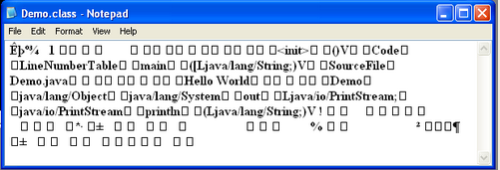](http://way2java.com/wp-content/uploads/2015/02/ima.png)

**Converting Java source code to bytecode is in known as compilation**. The bytecode is not in a readable format by the Microprocessor (as Microprocessor knows only one language – binary language).

2. **Interpretation stage (Execution stage)**

Here, Java interpreter comes into picture. **Java interpreter converts the bytecode into processor readable binary code**. The binary code is executed by the Microprocessor and given output. One thing is to be noticed here. Different OS will have different architectures. The Java interpreter converts the bytecode in the binary code understood by that OS. That is, the same bytecode, if executed on Windows gives binary code understood by Windows OS and if executed on UNIX gets binary code understood by the UNIX architecture. That is, interpreters are very different. The Java interpreter working on Windows is different from UNIX interpreter. You must load a OS compatible Java interpreter. Interpreter is a part of JDK. So, JDK’s are different for different OS. The interpreter is known as JVM (Java Virtual Machine).

Now, I think you are sure of why Java is called both compiled and interpreted language.

**More points to understand on compiled and interpreted stages**

**1.** Java code is compiled to bytecode. The bytecode is an intermediate code between java and the machine code. So you need an interpreter (the JVM) to execute the byte code.

**2.** Its simple, the bytecode is portable between OS. That is, the bytecode generated on OS can be executed on a different OS (provided you load, the compatible JDK which works on that OS).

**3.** At Interpretation stage, the performance increases due to JIT compiler.

**4.** It is very efficient to compile a high-level language into some intermediate bytecode and then interpreting it into low-level binary code.

**5.** Other styles of getting output from the source code is to compile a high-level language into native code (understood by the underlying OS) like C++, Pascal, FORTRAN and to interpret the high-level code directly to get output like Python, PHP, Ruby where no bytecode or binary code file is generated.

***Java Drawbacks***

Even though Java is projected as the most demanded language of the times, but has its own disadvantages. Of course, they are very minor in nature and need not be considered as drawbacks compared to the advantages it brings forward.

**Following is the list of Java Drawbacks**

a) **Slow performance**:

The first and foremost drawback everyone accepts is Java's slow speed of execution. Of course it is designed so to get the affect of platform-independent feature. Designers do trying to increase the performance in other aspects like the introduction of JIT (Just-In-Time) compiler.

b) **No support for low-level programming:**

With Java, low-level programming cannot be done as it is intended to be portable across platforms.

c) **Poor features in GUI:**

Java supports GUI controls but with less features. For example, an image cannot be placed on a button. The is overcome with the introduction of javax.swing package. Swing controls come with abundant features that are comparable with any GUI available.

d) **No control over garbage collection**:

Garbage collection is one of the built-in features of Java and is entirely managed by JVM. programmer is not given any handles to control the garbage collection to make coding simple. For this reason, Java does not come with delete(), free(), malloc() and sizeof() etc. functions.

**What Java Can't Do?**

Even though Java is termed as a production language where productivity is very high, but still it cannot do certain things. The productivity is possible due to the abundant classes available in [Java API](http://way2java.com/packages/predefined-packages-%e2%80%93-java-api/) that can cater to the very specific needs of the programmer. Java includes a few thousands of classes with [JDK 1.5](http://way2java.com/java-versions-2/jdk-1-5-java-se-5-version/) that takes care of many minute aspects of coding. Even though it is hyped so heavily, but **it cannot be used to develop low-level programming. Using Java, a new OS or new protocols or DVD burning software etc. cannot be programmed**.

***What is Java ? It is explained in Simple terms for a Beginner to get an idea of Java.***

**Java**, developed by **Sun Microsystems** and released to market in 1995, is a **high-level programming language** with many unparalleled features. It can be used to develop standalone applications, web applications ([applets](http://way2java.com/applets/applets-vs-applications/) and servlets), e-commerce applications, enterprise applications (like banking) and mobile applications. Very strong in LAN based as well as Client-Server programming with predefined methods.

Java is simple to practice, due to predefined classes and methods added to each version released now and then. To quote the simplicity, a [linked list program](http://way2java.com/collections/linkedlist-tutorial/) can be mastered just in 15 minutes. Within 15 minutes of learning, you can do more operations than what you have learnt in C/C++ coaching, like deleting a range of nodes etc. In socket programming, [one line of code is enough](http://way2java.com/networking/client-to-server-one-way-communication/) on client side just to send a simple message like "Hello Server" to server.

To say one word, there is no part of world where Java is not used. A Java student can get a job anywhere in the world. It is object-oriented and platform independent.

***Java and JDK***

**Many confusing concepts of Java and JDK are discussed in simple terms for a beginner.**

**1. What is a high-level language?**

A language is required to communicate with the computer hardware and operating system. A language comprises of **instructions** known as **commands**. Commands, earlier at the very beginning are written in **binary code**, later **punch cards** and still later in **assembly language**. But now-a-days, commands (or a language) are written in English that can be readable and writable by humans (binary language cannot be read by humans). A **high-level** computer language is written in English. Of course, all computer languages are high-level languages.

**2. What is Syntax?**

Like any other computer language, Java commands are written in with some **rules** that can be understood by the Compiler (Infact, even a human language like Telugu comes with rules known as grammar). These rules are known as **syntax**. Syntax varies with each language. Learning a language means learning syntax. The **high-level** instructions at runtime (execution time) are converted in numeric codes (known as binary code of 0 and 1s) and executed as Microprocessor understands only **binary code**.

**3. What is Java?**

* Java is a high-level programming language released to the world in the year November, 1995 by **Sun Microsystems** (now purchased by **Oracle** Corporation).
* Java is designed to be used in **distributed computing** using Internet (Servlets/JSP) and non-Internet (EJB). Java can be developed to work on a standalone system or in client/server communication.

**4. Where to use Java?**

1. There are **billions (not in millions) of devices** (applications) in the world as-on-today working on Java platform like **Web applications** (e-commerce), **mobile applications** (Android is in Java), **game consoles** (with J2ME) and standalone applications as in banks (**Finacle** – a banking software by Infosys is developed in Java) etc. To put in other words, there is no place in the world without Java.
2. With Java, you can play online games, chat with your friends, estimate the interest payable to your housing loan, design graphic 3D animations and online shopping etc.

**5. Who developed Java?**

Java is not a single man property. It is a corporate property of **Sun Microsystems** (now purchased by Oracle). A corporate contains number of employees. Java is developed by a team of software engineers headed by **James Gosling**. The first version of Java, JDK 1.0, was released to the market in **November, 1995**.

**6. What is the history of Java? OR how Java name came?**

The Java project started its way in 1991 to use in **set-top** boxes. Set-top box is a unit that connects a television set to an external signal. The signal is converted into content and displayed on television screen to the viewers; a visualization to network the digital devices with computers finally. The project was initially named as **Green project** and afterwards renamed to **Oak**, on the name of **Oak tree** that stood in the premises of Sun Microsystems. Finally, at the time of release, Oak was renamed (as the name Oak was existing by that time as a name of a software company) as **Java**, as suggested by **Kim Polese**, a Oak product manager in the team of James Gosling and the discussion came when they were in a coffee-shop (other names stood for final selection were DNA and Silk). Java (Jawa, in Indonesian language) is an island in Indonesia famous for coffee plantations and volcanic mountains.

**Gosling’s** aim was to develop a virtual machine that can "**write Once, Run Anywhere**", meaning compile once and run on any system. Another aim was to make Java as simple as possible avoiding many confusing concepts of other languages so that the programmer should feel comfortable to learn and practice. Due to its **simplicity**, Java became very popular within no time and the work on the Java language development did not see back. Whenever, Java is added with more functionality with new classes and packages, the Sun Microsystems releases a new Java (JDK) version. The major changes to Java came with **Java 2** (JDK 1.2) version, released in 1998, that included three components – **J2ME** (Java 2 Micro Edition), **J2SE** (Java 2 Standard Edition), **J2EE** (Java 2 Enterprise Edition).

**7. What is JDK?**

**JDK** stands for **Java Development Kit**. JDK is a software that compiles and runs a Java program.

**8. Does Java freely downloadable?**

Definitely. Java is a freely downloadable software.

**9. Why should we write a Java program in the latest version of JDK?**

Java **Architects** motto, from the day one to to-date (from Jdk 1.0 to JDK 1.8), is how to make Java **simple** to practice and increase **performance**. To reach this goal, Java is added with new classes with every version. New versions come with added features like **performance**, **security updates** and **JVM tuning** etc. Using the latest version gets you all these benefits intended by the Architects.

**10. What is the difference between a program and an application?**

An application has got a task to perform. To perform the task, an application comprises of number of programs. That is, **number of programs integrated is an application**. Example: **Banking application** having number of operations like debit, credit, money transfer etc., **e-commerce application** with operations like shopping cart, billing, money transfer etc.

**11. Why should we choose Java only and not other languages?**

**Following are the underlying principles of Java development.**

1. **Platform Independent:** A Java program can be compiled on any platform (OS) and executed on any other platform. That is, you can compile a Java program on DOS and execute it on Linux or Macintosh. This is not possible with any language as-on-day.
2. **Reliability:** Java is a robust and reliable language. JVM executing on a system, does not crash the host operating system even with fatal errors.
3. **Secure:** Java, comparative with other languages of today, is very secure. JAAS (Java Authorization and Authentication System) gives customized security to a Java application.

**12. What are features of Java?**

All the Java features can be described in one sentence:

"**Platform-Independent, Portable, Simple and Familiar, Object-Oriented, Architecture Neutral, Robust, Internet-based, Implicit Memory Management, Interpreted, Distributed, Multithreaded, Dynamic, Secured, High-Performance, Free from Language**".

**13. Is platform and language one and the same? Java is a platform or language?**

Generally as we talk, a platform means operating system on which programs run. The popular platform are Windows, Linus and Macintosh. A platfrom requires hardware.

We call Java is a platform (to call as Java platform) is a software that runs on the top of hardware and OS.

Java platform comes with JVM (Java Virtual Machine) to run the Java applications and standard libraries known as Java API (Application Programmng Interface).

**14. Is Java and JavaScript one and the same?**

Never, they are not. Java is **object-oriented** language where as JavaScript is **object-based** language. The original name of JavaScript is LiveScript. Both are very different in their syntax and applications.

**15. Does Java comes with any drawbacks?**

Yes, there are drawbacks.

Even though Java is hyped as the most demanded language, it comes with its own disadvantages, of course, minor to think and not bothered much with the advantages it brings with. These disadvantages, what the people call, are purposefully committed by the designers to make Java more beneficial to the end users and easy to practice to developers.

1. **Lack of performance:**

Java is slower in execution compared to C/C++. The Java designers aimed at platform independence and simplicity rather than its performance. The execution speed is increased with the introduction of JIT (Just-In-Time) compiler. It is really a trade-off in the selection of Java for product development.

1. **Lack of support for low-level programming:**

Java is not suitable for low-level system programming. It is difficult to write platform specific code as Java is intended to be platform-independent.

1. **Lack of features in GUI:**

The Core Java supports GUI; but its controls come with very poor features. Of course, it is purposefully designed so to give the same look of GUI controls the operating system supports. But more features are added in javax.swing package, features unparallel and comparable to any other GUI in the market.

1. **Lack of control over garbage collection:**

Programmers are not given any handles to control the garbage (unwanted objects whose job is over in the execution) generated while the execution is going on. The reason is Java designers wanted to make Java simple to practice and thereby planned to collect the garbage implicitly without any extra efforts by the programmer.

***Java Main Features explained one-by-one in Simple words for a Beginner.***

Java was released to market in **1995** with its first version **JDK 1.0**. From day one, it is treated as an important language used to develop many applications that are increasing every day; the latest being **Android**. As on today, more than **3 billion** devices are working on Java. All this popularity is due to Java’s in-built features starting from JDK 1.0. Every release (as on today, JDK 1.8) adds new features that make programming still simple to Developer or execution performance increases.

This note gives the main features released with JDK 1.0. Later we see every release.

All the features of Java can be put in a single line as follows.

"**Platform-Independent, Portable, Simple and Familiar, Object-Oriented, Architecture Neutral, Robust, Internet-based, Implicit Memory Management, Interpreted, Distributed, Multithreaded, Dynamic, Secured, High-Performance, Free from Language**".

Let us explore each feature in detail.

**a) Platform-Independent**

Many novices confuse here. They simple say, "because Java can be executed on any platform, Java is known as platform-independent language". It is totally a wrong conception, they understood in colleges. If the definition is correct, then almost I can prove every language is platform-independent. For example, you know well that C-lang can be executed on Linux and DOS (two languages). Then do you call C-lang as platform-independent? No, never. Then what is the correct meaning.

**What is platform-dependent?**

If a C-lang program is compiled on DOS, the generated .exe file executes only on **DOS**. If taken to **Linux** or some other OS, it never executes. That is, a C-lang program, where it is compiled, on the same OS it must be executed. This is known as platform-dependency which is very contrary to Java.

**Then, what is platform-independent?**

With Java, the whole scenario changes. Now, compile Java program on **DOS**. The generated **.class** file (equivalent to .exe file of C-lang) can be executed on any platform (OS), you know. That is, compile once on any platform and execute or run on any platform later as per your convenience. **This is known as platform-independent, a unique feature of Java.**

**2. Portable**

What made Java platform-independent? The **.class** file of Java contains bytecode (C-lang, .exe file contains binary code) and this **bytecode makes Java platform-independent**. That is, while you develop a software product in Java in your software company, just compile on the platform available in the work place. Then port it or carry the **.class** file to any client and execute it without bothering what platform (operating system) the client is loaded with. **This is known as portability.**

**3. Simple and Familiar**

When you look at Java code, you feel as if you have seen (or familiar with) Java earlier. It is because the Java follows the same style of variable declarations of C-lang and also method declarations, arrays and functions (in Java, C-lang functions are known as methods). Java excluded many confusing concepts of C/C++ to make programming simple to develop.

1. Java does out support **pointers**.
2. "**goto**" keyword is eliminated as a Programmer looses control over the control flow.
3. Does not support **unsigned data types**. For that matter, unsigned is not a keyword of Java at all.
4. Facility of **operator overloading** removed.
5. No "**# define**", known as **pre-processor directives**.
6. **Multiple inheritance** is not supported but supports multilevel and hierarchical.
7. **Unassigned** variables are not assigned with garbage values.
8. **Memory management** either creation or destruction is implicit. As memory management is implicit, Java does not support functions like **malloc()**, **calloc()**, **sizeof()**, **delete()** and **free()** etc.
9. Does not support **structures**, **templates** and **unions**.

**4. Object-Oriented**

All the three OOPs concepts, **encapsulation**, **inheritance** and **polymorphism**, are supported by Java.

* With encapsulation, one instance variable can be given multiple values.
* Reusability of code is maximum with inheritance and composition.
* Same method gives different outputs when executed at different times is known as polymorphism and Java takes advantage of it.

**5. Architecture Neutral**

Java source file compilation results in an executable file known as **.class** file. **.class** file contains bytecode. **Bytecode** includes some square boxes, unknown and unreadable characters, some scattered English characters and this bytecoe is not in understandable format to **Microprocessor**. The bytecode is converted by the JVM (execution part of JDK) into binary code understood by that particular OS. The same bytecode is converted into different binary formats that can be executed by the underlying OS architecture. Java programs does not depend on the architecture of OS. Just load a compatible JDK for the OS.

**6. Robust**

Robustness means user friendliness of the language. Java does not allow the user to commit mistakes to the maximum extent.

* Unassigned variables do not take garbage values.
* Strong-type checking of variables and objects including in casting operations.
* Does not allow to give the size of the array in array initialization. In C/C++, it is optional.
* Comes with very effective exception handling mechanism added with extra features in JDK 1.7.
* Java eliminates many memory management functions.

**7. Internet-based**

Java, from the date of inception, supported applets. **Applets are special type of Java programs with different syntax meant to be executed in Browser’s environment.** Applets are used on client-side in Servlet based communication. Java supports Internet-based (using Web) programming through applets (on client-side) and **Servlets** (on server-side).

**8. Implicit Memory Management – Garbage Collection**

Java program can forget about memory management as JVM takes care of. For this reason, Java does not support memory management functions like malloc(), calloc() and sizeof() etc.

Java comes with an attractive feature called garbage collection. While a Java program is being run, the objects and variables which are not used in further part of the program (known as garbage) are removed by a special thread called garbage collector.

**9. Interpreted**

Different languages are there that are compiled (C/C++), parsed (HTML and XML) and interpreted (JavaScript and VBScript) etc. But Java is both compiled and interpreted. The source code is compiled (into bytecode) and and **byte code is interpreted** (into binary code). From source code to output, two stages exist – **compilation** and **interpretation**.

**10. Distributed**

Java is a good supporter of networking. It supports LAN (Socket) communication through java.net package, Web communication through Servlets and JSP (Java Server Pages) and distributed communication with RMI (Remote Method Invocation) and EJB (Enterprise Java Beans).

**11. Multithreaded**

Java supports multitasking through multithreading. A process can be divided into a number of blocks of statements. Each block can be names as a thread. That is, a process can be divided into a number of threads and each thread can be given a different task. The advantage of threads is if one thread stopped its execution by some reason, the execution can be transferred to another thread. The result is reduced Microprocessor idle time. Output will come earlier than expected.

***Backslash Java***

Like C/C++, Java also comes with a group of characters treated as a single character and this single character also represents an ASCII value. These characters are known as **escape sequences** and precede (starts) with a **backward slash \** like **\n** and **\t** etc. The name is so derived as they escape the normal flow or printing of characters. The **\n** escapes of printing in the same line and instead prints in a separate line.

The following table prints the list of escape sequences supported by Java.

|  |  |  |
| --- | --- | --- |
| **Escape sequence** | **ASCII value** | **Meaning** |
| **\b** | **8** | **backspace** |
| **\t** | **9** | **tab** |
| **\n** | **10** | **new line** |
| **\f** | **12** | **form feed** |
| **\r** | **13** | **carriage return** |
| **\"** | **34** | **double quote** |
| **\'** | **39** | **single quote** |
| **\\** | **92** | **backslash** |

Following program shows the way to print the ASCII values of escape sequences (the same procedure you followed in C/C++).

***public class StringCapitalize***

***{***

***public static void main(String args[])***

***{***

***System.out.println("\\b ASCII value: " + (int)'\b');***

***System.out.println("\\t ASCII value: " + (int)'\t');***

***System.out.println("\\n ASCII value: " + (int)'\n');***

***System.out.println("\\f ASCII value: " + (int)'\f');***

***System.out.println("\\r ASCII value: " + (int)'\r');***

***System.out.println("\\\" ASCII value: " + (int)'\"');***

***System.out.println("\\' ASCII value: " + (int)'\'');***

***System.out.println("\\\\ ASCII value: " + (int)'\\');***

***}***

***}***

Observe the **println()** statements in the above code; all confusing with multiple backslashes. This is where the programmer should be careful with backslash menace.

*Backslash Java Menace*

***String str1 = “hello\sir”;  
System.out.println(“hello\sir”);***

The above two statements do not compile and compiler raises "**illegal escape character**" regarding **\s**. Any letter suffixed to **\** is treated as an **escape sequence** by the JVM. Now **\s** is checked with the standard list of escape sequences and did not find, the JVM raised an error. Suppose if you would like to have really **\s** in the code, instead of one **\** place two **\\**. **\\** is also an escape sequence and JVM places a single slash (instead of two slashes) in the output. The following works nice.

***String str1 = “hello\\sir”;  
System.out.println(“hello\\sir”);.***

A beginner should take care of the usage of Backslash Java.

In writing the regular expressions also, it must be taken care of.

***String str2 = str1.replaceAll(“\\d”, “OK”);***

The above statement is used in "Java String replaceAll" to replace each digit in the string with **OK**. The **\\d** is a **regular expression** where **d** represents each digit in the string. It is actually **\d** is required; but **\d** raises an error. Instead, **\\d** is placed which is converted to **\d** by the JVM and evaluated. This is where the programmer should be capable of.

Java Escape Sequences

**"Escape sequence is a character which escapes normal sequence of output (evaluation)". Escape sequences are very common in a language. Escape sequence precedes with a \ (backslash). For example, \n stands for new line; even though it looks two characters, Java treats them as one character with ASCII code of 10. Escape sequence, being a single character, should be put within single quotes.**

**Observe the following simple code on Escape Sequences**

***public class Demo{***

***public static void main(String args[]) {***

***int x = '\t'; // enclosed within single quotes***

***System.out.println(x); // prints 9***

***int y = '\n';***

***System.out.println(y); // prints 10***

***}***

***}***

You can try for other escape characters also what their ASCII codes.

Java also comes Escape Sequences and the list if given here under.

|  |  |
| --- | --- |
| Escape Sequence | Meaning |
| \n | Gives a new line |
| \t | Gives one tab space (Java gives 6 spaces) |
| \" | Prints just double quotes, " |
| \' | Prints just single qutotes, ' |
| \r | Carriage return; The second line comes to the beginning of the line; that is, comes to extreme left where a new line begins. |
| \b | Moves one space backwards. The character preceded to \b is deleted |
| \\ | prints one slash (instead of two) |
| \f | Form feed |

**Following code gives some Escape Sequences usage.**

***public class Demo{***

***public static void main(String args[]) {***

***System.out.println("abc\ndef"); // abc and def are given in two lines***

***System.out.println("ab\bcd"); // prints acd***

***System.out.println("ab \bcd"); // prints abcd, the space before \b is gone***

***System.out.println("abcdefghij");   
 // prints ab cd, gives 3 spaces between ab and cd***

***System.out.println("ab\tcd");   
// prints ab cd, gives 3 spaces between ab and cd***

***System.out.println("a\"bc\"d"); // prints a"bc"d***

***System.out.println("a\'bc\'d"); // prints a'bc'd***

***}***

***}***

### Java Development Kit (JDK):

Java Development Kit contains two parts. One part contains the utilities like javac, debugger, jar which helps in compiling the source code (.java files) into byte code (.class files) and debug the programs. The other part is the JRE, which contains the utilities like java which help in running/executing the byte code. If we want to write programs and run them, then we need the JDK installed.

### Java Compiler (javac):

javac is the executable/application which compiles the .java source files into the byte code (.class files). javac is included in JDK.

### Java Run-time Environment (JRE):

Java Run-time Environment helps in running the programs. JRE contains the JVM, the java classes/packages and the run-time libraries. If we do not want to write programs, but only execute the programs written by others, then JRE alone will be sufficient.

### Java Virtual Machine (JVM):

Java Virtual Machine is important part of the JRE, which actually runs the programs (.class files), it uses the java class libraries and the run-time libraries to execute those programs. Every operating system(OS) or platform will have a different JVM.

### Java Executable (java):

java is the application which runs/executes the .class files. This internally calls the JVM for running the programs.

### Just In Time Compiler (JIT):

JIT is a module inside the JVM which helps in compiling certain parts of byte code into the machine code for higher performance. Note that only certain parts of byte code will be compiled to the machine code, the other parts are usually interpreted and executed.

***Java Documentation Comments***

The Java language supports three types of comments:

|  |  |
| --- | --- |
| ***Comment*** | ***Description*** |
| */* text */* | *The compiler ignores everything from /* to */.* |
| *// text* | *The compiler ignores everything from // to the end of the line.* |
| */** documentation */* | *This is a documentation comment and in general its called doc comment. The JDK javadoc tool uses doc comments when preparing automatically generated documentation.* |

This tutorial is all about explaining Javadoc. We will see how we can make use of Javadoc for generating useful documentation for our Java code.

***What is Javadoc?***

Javadoc is a tool which comes with JDK and it is used for generating Java code documentation in HTML format from Java source code which has required documentation in a predefined format.

Following is a simple example where red part of the code represents Java comments:

***/\*\****

***\* The HelloWorld program implements an application that***

***\* simply displays "Hello World!" to the standard output.***

***\****

***\* @author Zara Ali***

***\* @version 1.0***

***\* @since 2014-03-31***

***\*/***

***public class HelloWorld {***

***public static void main(String[] args) {***

***/* Prints Hello, World! on standard output. */***

***System.out.println("Hello World!");***

***}***

***}***

You can include required HTML tags inside the description part, For example, below example makes use of <h1>....</h1> for heading and <p> has been used for creating paragraph break:

***/\*\****

***\* <h1>Hello, World!</h1>***

***\* The HelloWorld program implements an application that***

***\* simply displays "Hello World!" to the standard output.***

***\* <p>***

***\* Giving proper comments in your program makes it more***

***\* user friendly and it is assumed as a high quality code.***

***\****

***\****

***\* @author Zara Ali***

***\* @version 1.0***

***\* @since 2014-03-31***

***\*/***

***public class HelloWorld {***

***public static void main(String[] args) {***

***/* Prints Hello, World! on standard output.***

***System.out.println("Hello World!");***

***}***

***}***

The javadoc Tags:

The javadoc tool recognizes the following tags:

|  |  |  |
| --- | --- | --- |
| **Tag** | **Description** | **Syntax** |
| @author | Adds the author of a class. | @author name-text |
| {@code} | Displays text in code font without interpreting the text as HTML markup or nested javadoc tags. | {@code text} |
| {@docRoot} | Represents the relative path to the generated document's root directory from any generated page | {@docRoot} |
| @deprecated | Adds a comment indicating that this API should no longer be used. | @deprecated deprecated-text |
| @exception | Adds a **Throws** subheading to the generated documentation, with the class-name and description text. | @exception class-name description |
| {@inheritDoc} | Inherits a comment from the **nearest** inheritable class or implementable interface | Inherits a comment from the immediate surperclass. |
| {@link} | Inserts an in-line link with visible text label that points to the documentation for the specified package, class or member name of a referenced class. T | {@link package.class#member label} |
| {@linkplain} | Identical to {@link}, except the link's label is displayed in plain text than code font. | {@linkplain package.class#member label} |
| @param | Adds a parameter with the specified parameter-name followed by the specified description to the "Parameters" section. | @param parameter-name description |
| @return | Adds a "Returns" section with the description text. | @return description |
| @see | Adds a "See Also" heading with a link or text entry that points to reference. | @see reference |
| @serial | Used in the doc comment for a default serializable field. | @serial field-description | include | exclude |
| @serialData | Documents the data written by the writeObject( ) or writeExternal( ) methods | @serialData data-description |
| @serialField | Documents an ObjectStreamField component. | @serialField field-name field-type field-description |
| @since | Adds a "Since" heading with the specified since-text to the generated documentation. | @since release |
| @throws | The @throws and @exception tags are synonyms. | @throws class-name description |
| {@value} | When {@value} is used in the doc comment of a static field, it displays the value of that constant: | {@value package.class#field} |
| @version | Adds a "Version" subheading with the specified version-text to the generated docs when the -version option is used. | @version version-text |

Example:

Following program uses few of the important tags available for documentation comments. You can make use of other tags based on your requirements.

The documentation about the AddNum class will be produced in HTML file AddNum.html but same time a master file with a name index.html will also be created.

*import java.io.*;*

*/\*\**

*\* <h1>Add Two Numbers!</h1>*

*\* The AddNum program implements an application that*

*\* simply adds two given integer numbers and Prints*

*\* the output on the screen.*

*\* <p>*

*\* <b>Note:</b> Giving proper comments in your program makes it more*

*\* user friendly and it is assumed as a high quality code.*

*\**

*\* @author Zara Ali*

*\* @version 1.0*

*\* @since 2014-03-31*

*\*/*

*public class AddNum {*

*/\*\**

*\* This method is used to add two integers. This is*

*\* a the simplest form of a class method, just to*

*\* show the usage of various javadoc Tags.*

*\* @param numA This is the first paramter to addNum method*

*\* @param numB This is the second parameter to addNum method*

*\* @return int This returns sum of numA and numB.*

*\*/*

*public int addNum(int numA, int numB) {*

*return numA + numB;*

*}*

*/\*\**

*\* This is the main method which makes use of addNum method.*

*\* @param args Unused.*

*\* @return Nothing.*

*\* @exception IOException On input error.*

*\* @see IOException*

*\*/*

*public static void main(String args[]) throws IOException*

*{*

*AddNum obj = new AddNum();*

*int sum = obj.addNum(10, 20);*

*System.out.println("Sum of 10 and 20 is :" + sum);*

*}*

*}*

Now, process above AddNum.java file using javadoc utility as follows:

***$ javadoc AddNum.java***

***Loading source file AddNum.java...***

***Constructing Javadoc information...***

***Standard Doclet version 1.7.0_51***

***Building tree for all the packages and classes...***

***Generating /AddNum.html...***

***AddNum.java:36: warning - @return tag cannot be used in method with void return type.***

***Generating /package-frame.html...***

***Generating /package-summary.html...***

***Generating /package-tree.html...***

***Generating /constant-values.html...***

***Building index for all the packages and classes...***

***Generating /overview-tree.html...***

***Generating /index-all.html...***

***Generating /deprecated-list.html...***

***Building index for all classes...***

***Generating /allclasses-frame.html...***

***Generating /allclasses-noframe.html...***

***Generating /index.html...***

***Generating /help-doc.html...***

***1 warning***

***$***

You can check all the generated documentation here:

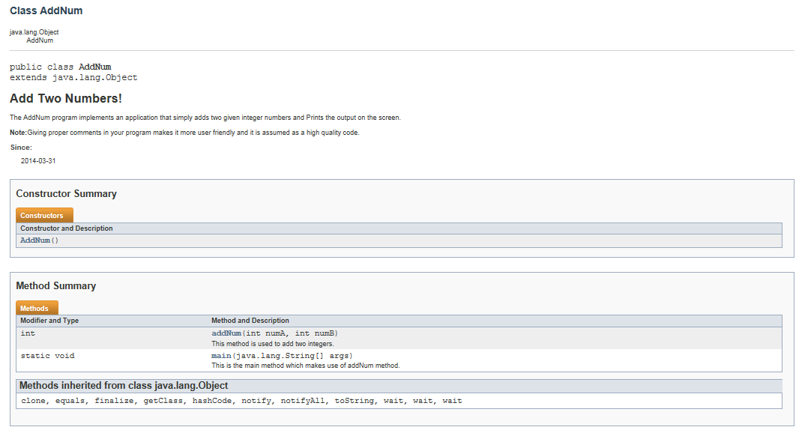

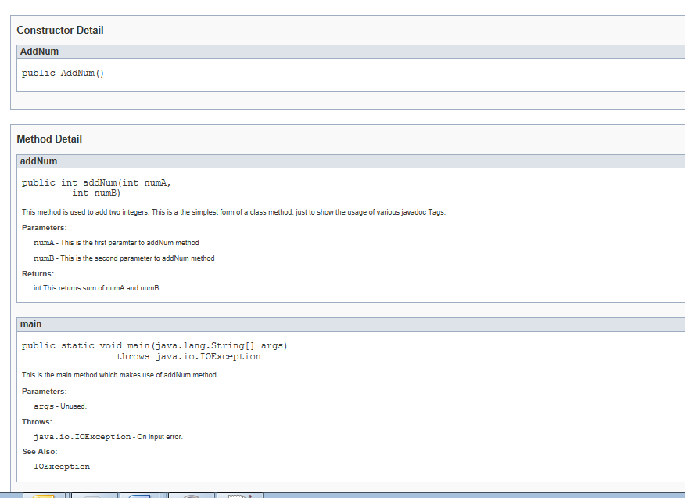

**Unreachable Code :**

Every statement in any java program must be reachable i.e every statement must be executable at least once in any one of the possible flows. If any code can not be executable in any of the possible flows, then it is called unreachable code. Unreachable code in java is a compile time error.

Look at the following example. Try to compile this example.

*public class UnreachableCodeInJava{*

*void UnreachableCode_method(boolean b)    {*

*if(b){*

*return;*

*}*

*else {*

*return;*

*}*

*System.out.println("Unreachable Statement");*

*//Compile Time Error : Unreachable Code*

*}*

*}*

In this example, Line 14 gives compile time error : Unreachable Code. Because this statement cannot be reached in any of the flows. If boolean “b” is true, then if block will be executed and control will be returned. If boolean “b” is false, then else block will be executed and control will be returned. So, in both the flows control is not coming to Line 14. It remains unreachable. Hence, it gives compile time error.

*Have a look at this example.*

***public class UnreachableCodeInJava{***

***void UnreachableCode_method(boolean b)    {***

***System.out.println("Reachable Statement");***

***return;***

***System.out.println("Unreachable Statement");     //Compile Time Error***

***}***

***}***

In this example, UnreachableCode_method() has only one flow. In this flow only, all the statements has to be executed at least once. But, control is returning at second statement only. So, Third statement becomes unreachable.

## Dead Code :

Dead code is also unreachable code, but dead code doesn’t give compile time error. It just gives you a warning.  
For example,

***public class UnreachableCodeInJava{***

***void UnreachableCode_method(boolean b)    {***

***System.out.println("Reachable Statement");***

***if(true)        {***

***return;***

***}***

***System.out.println("Unreachable Statement");     //Dead Code***

***}***

***}***

In the above example, if block will be always executed as we are passing constant value “true” to it. So, Line 12 becomes unreachable. Although compiler will not complain about it. It just gives you a warning saying that it is a dead code.

Now, make little modification to above example.Replace the if block with while block.Compile it and see what happens.

***public class UnreachableCodeInJava{***

***static void UnreachableCode_method(boolean b)    {***

***System.out.println("Reachable Statement");***

***while(true)        {***

***return;***

***}***

***System.out.println("Unreachable Statement");     //Compile Time Error***

***}***

***}***

This example gives compile time error : Unreachable code. But why? Why compiler changes its mind when it sees while block? Why it does not complain about unreachable code after if block.?

This is because,The rules of unreachable code for different blocks like constructors, methods, try, catch, if, for, while etc are defined individually in the Java Language Specification. According to Java Language Specification, The conditional expression of If block will not be evaluated at compile time to decide the unreachable code. That’s why you will not get compile time error in case of if block.

***Unreachable Statements***

It is a compile-time error if a statement cannot be executed because it is unreachable.

This section is devoted to a precise explanation of the word "reachable." The idea is that there must be some possible execution path from the beginning of the constructor, method, instance initializer, or static initializer that contains the statement to the statement itself. The analysis takes into account the structure of statements. Except for the special treatment of while, do, and for statements whose condition expression has the constant value true, the values of expressions are not taken into account in the flow analysis.

**For example, a Java compiler will accept the code:**

*{*

*int n = 5;*

*while (n > 7) k = 2;*

*}*

even though the value of n is known at compile time and in principle it can be known at compile time that the assignment to k can never be executed.

The rules in this section define two technical terms:

* whether a statement is reachable
* whether a statement can complete normally

The definitions here allow a statement to complete normally only if it is reachable.

To shorten the description of the rules, the customary abbreviation "iff" is used to mean "if and only if."

A reachable break statement exits a statement if, within the break target, either there are no try statements whose try blocks contain the break statement, or there are try statements whose try blocks contain the break statement and all finally clauses of those try statements can complete normally.

This definition is based on the logic around "attempts to transfer control" in [§14.15](http://docs.oracle.com/javase/specs/jls/se7/html/jls-14.html#jls-14.15).

A continue statement continues a *do* statement if, within the do statement, either there are no try statements whose try blocks contain the continue statement, or there are try statements whose try blocks contain the continue statement and all finally clauses of those try statements can complete normally.

**The rules are as follows:**

* The block that is the body of a constructor, method, instance initializer, or static initializer is reachable.
* An empty block that is not a switch block can complete normally iff it is reachable.

A non-empty block that is not a switch block can complete normally iff the last statement in it can complete normally.

The first statement in a non-empty block that is not a switch block is reachable iff the block is reachable.

Every other statement S in a non-empty block that is not a switch block is reachable iff the statement preceding S can complete normally.

* A local class declaration statement can complete normally iff it is reachable.
* A local variable declaration statement can complete normally iff it is reachable.
* An empty statement can complete normally iff it is reachable.
* A labeled statement can complete normally if at least one of the following is true:
  + The contained statement can complete normally.
  + There is a reachable break statement that exits the labeled statement.

The contained statement is reachable iff the labeled statement is reachable.

* An expression statement can complete normally iff it is reachable.
* An if-then statement can complete normally iff it is reachable.

The then-statement is reachable iff the if-then statement is reachable.

An if-then-else statement can complete normally iff the then-statement can complete normally or the else-statement can complete normally.

The then-statement is reachable iff the if-then-else statement is reachable.

The else-statement is reachable iff the if-then-else statement is reachable.

This handling of an if statement, whether or not it has an else part, is rather unusual. The rationale is given at the end of this section.

* An assert statement can complete normally iff it is reachable.
* A switch statement can complete normally iff at least one of the following is true:
  + The switch block is empty or contains only switch labels.
  + The last statement in the switch block can complete normally.
  + There is at least one switch label after the last switch block statement group.
  + The switch block does not contain a default label.
  + There is a reachable break statement that exits the switch statement.
* A switch block is reachable iff its switch statement is reachable.
* A statement in a switch block is reachable iff its switch statement is reachable and at least one of the following is true:
  + It bears a case or default label.
  + There is a statement preceding it in the switch block and that preceding statement can complete normally.
* A while statement can complete normally iff at least one of the following is true:
  + The while statement is reachable and the condition expression is not a constant expression ([§15.28](http://docs.oracle.com/javase/specs/jls/se7/html/jls-15.html#jls-15.28)) with value true.
  + There is a reachable break statement that exits the while statement.

The contained statement is reachable iff the while statement is reachable and the condition expression is not a constant expression whose value is false.

* A do statement can complete normally iff at least one of the following is true:
  + The contained statement can complete normally and the condition expression is not a constant expression ([§15.28](http://docs.oracle.com/javase/specs/jls/se7/html/jls-15.html#jls-15.28)) with value true.
  + The do statement contains a reachable continue statement with no label, and the do statement is the innermost while, do, or for statement that contains that continue statement, and the continue statement continues that do statement, and the condition expression is not a constant expression with value true.
  + The do statement contains a reachable continue statement with a label L, and the do statement has label L, and the continue statement continues that do statement, and the condition expression is not a constant expression with value true.
  + There is a reachable break statement that exits the do statement.

The contained statement is reachable iff the do statement is reachable.

* A basic for statement can complete normally iff at least one of the following is true:
  + The for statement is reachable, there is a condition expression, and the condition expression is not a constant expression ([§15.28](http://docs.oracle.com/javase/specs/jls/se7/html/jls-15.html#jls-15.28)) with value true.
  + There is a reachable break statement that exits the for statement.

The contained statement is reachable iff the for statement is reachable and the condition expression is not a constant expression whose value is false.

* An enhanced for statement can complete normally iff it is reachable.
* A break, continue, return, or throw statement cannot complete normally.
* A synchronized statement can complete normally iff the contained statement can complete normally.

The contained statement is reachable iff the synchronized statement is reachable.

* A try statement can complete normally iff both of the following are true:
  + The try block can complete normally or any catch block can complete normally.
  + If the try statement has a finally block, then the finally block can complete normally.
* The try block is reachable iff the try statement is reachable.
* A catch block C is reachable iff both of the following are true:
  + Either the type of C's parameter is an unchecked exception type or Throwable; or some expression or throw statement in the try block is reachable and can throw a checked exception whose type is assignable to the parameter of the catch clause C.

An expression is reachable iff the innermost statement containing it is reachable.

* + There is no earlier catch block A in the try statement such that the type of C's parameter is the same as or a subclass of the type of A's parameter.
* The Block of a catch block is reachable iff the catch block is reachable.
* If a finally block is present, it is reachable iff the try statement is reachable.

One *might expect* the if statement to be handled in the following manner:

* An if-then statement can complete normally iff at least one of the following is true:
  + The if-then statement is reachable and the condition expression is not a constant expression whose value is true.
  + The then-statement can complete normally.

The then-statement is reachable iff the if-then statement is reachable and the condition expression is not a constant expression whose value is false.

* An if-then-else statement can complete normally iff the then-statement can complete normally or the else-statement can complete normally.

The then-statement is reachable iff the if-then-else statement is reachable and the condition expression is not a constant expression whose value is false.

The else-statement is reachable iff the if-then-else statement is reachable and the condition expression is not a constant expression whose value is true.

This approach would be consistent with the treatment of other control structures. However, in order to allow the if statement to be used conveniently for "conditional compilation" purposes, the actual rules differ.

As an example, the following statement results in a compile-time error:

while (false) { x=3; }

because the statement x=3; is not reachable; but the superficially similar case:

if (false) { x=3; }

does not result in a compile-time error. An optimizing compiler may realize that the statement x=3; will never be executed and may choose to omit the code for that statement from the generated class file, but the statement x=3; is not regarded as "unreachable" in the technical sense specified here.

The rationale for this differing treatment is to allow programmers to define "flag variables" such as:

static final boolean DEBUG = false;

and then write code such as:

if (DEBUG) { x=3; }

The idea is that it should be possible to change the value of DEBUG from false to true or from true to false and then compile the code correctly with no other changes to the program text.

This ability to "conditionally compile" has a significant impact on, and relationship to, binary compatibility ([§13](http://docs.oracle.com/javase/specs/jls/se7/html/jls-13.html)). If a set of classes that use such a "flag" variable are compiled and conditional code is omitted, it does not suffice later to distribute just a new version of the class or interface that contains the definition of the flag. A change to the value of a flag is, therefore, not binary compatible with pre-existing binaries ([§13.4.9](http://docs.oracle.com/javase/specs/jls/se7/html/jls-13.html#jls-13.4.9)). (There are other reasons for such incompatibility as well, such as the use of constants in case labels in switch statements; see [§13.4.9](http://docs.oracle.com/javase/specs/jls/se7/html/jls-13.html#jls-13.4.9).)











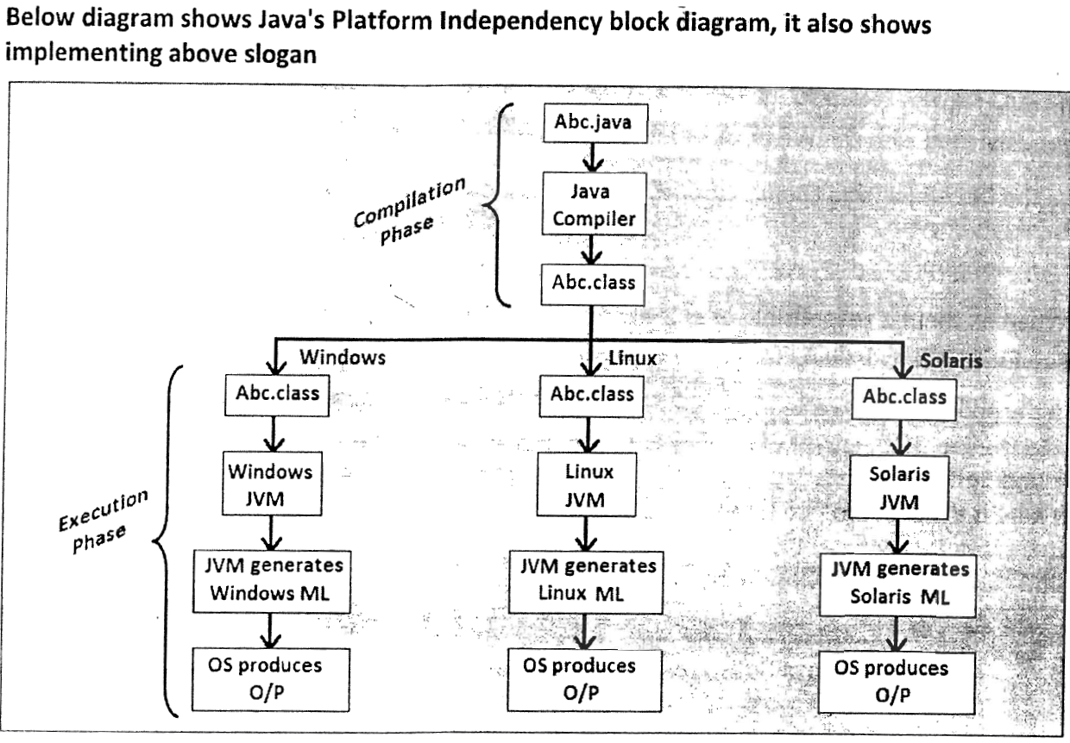

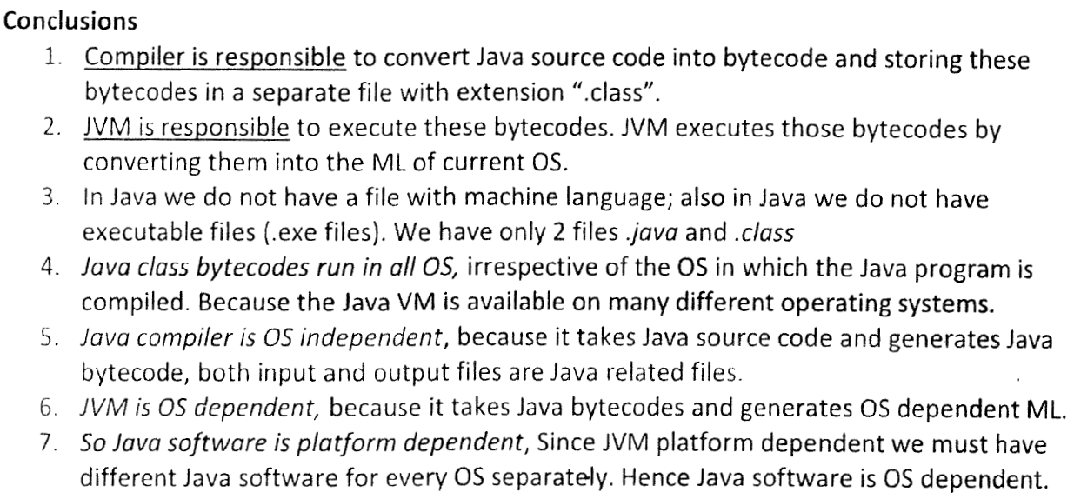

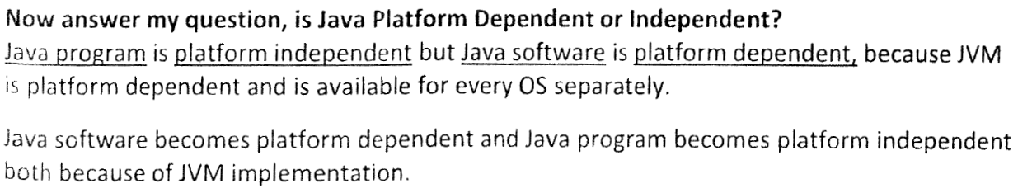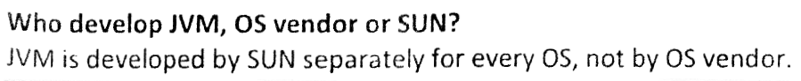

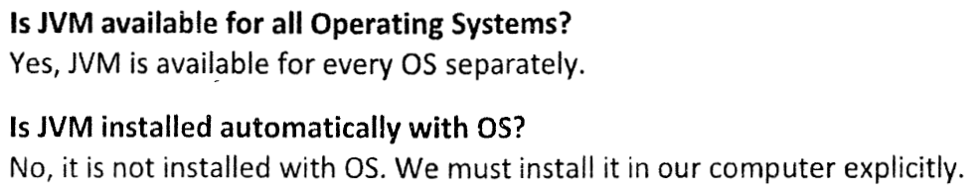

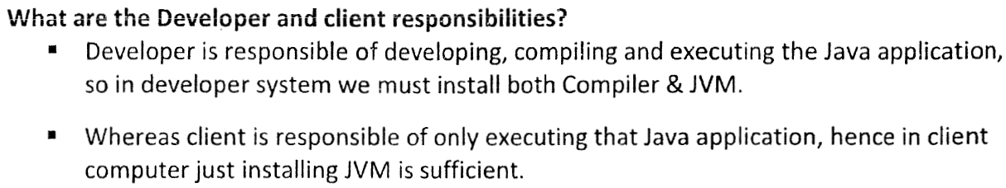

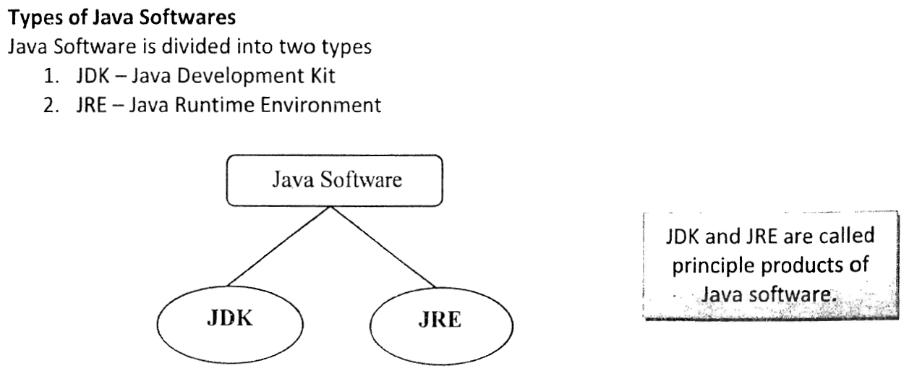

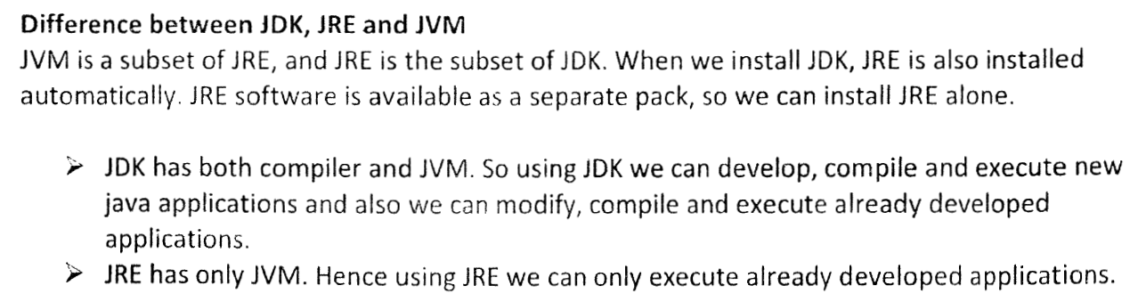



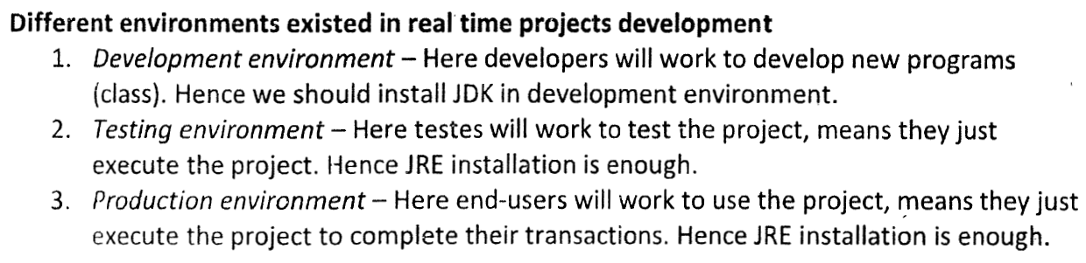

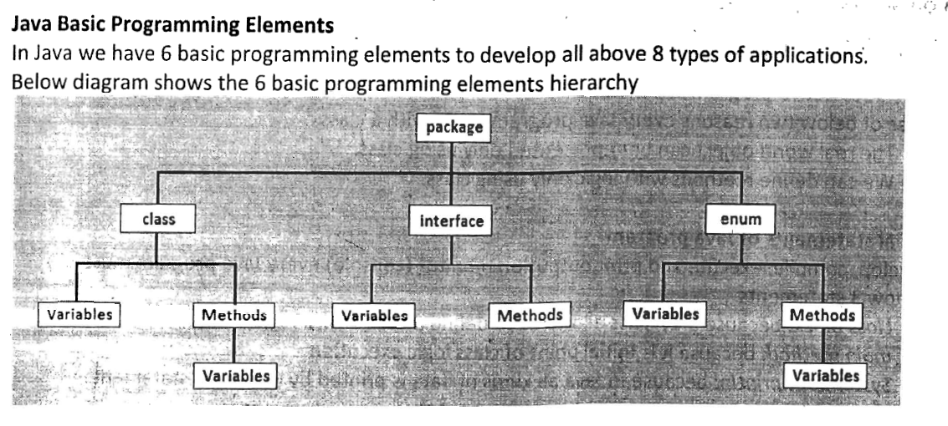

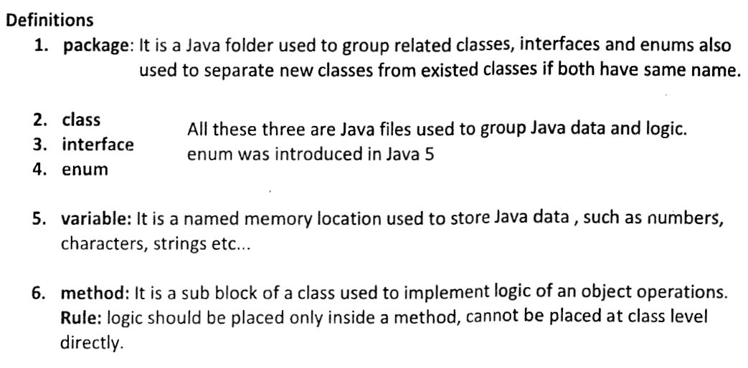

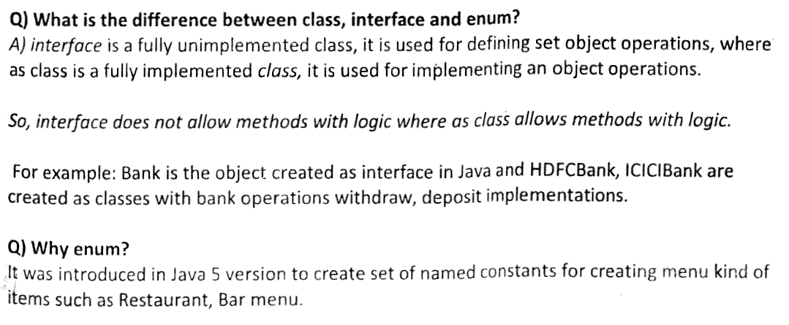

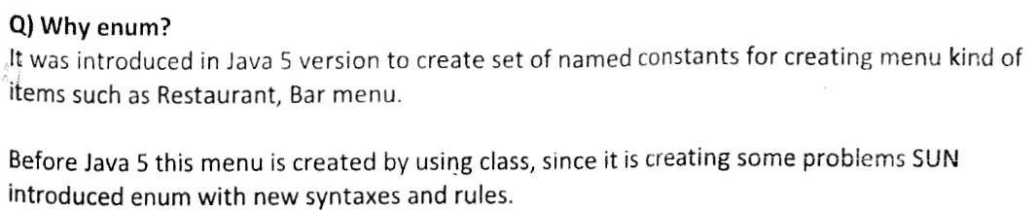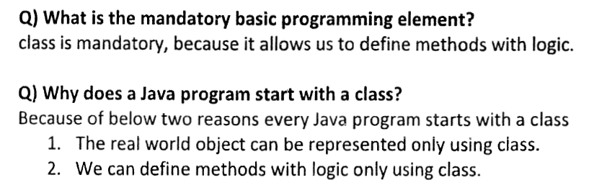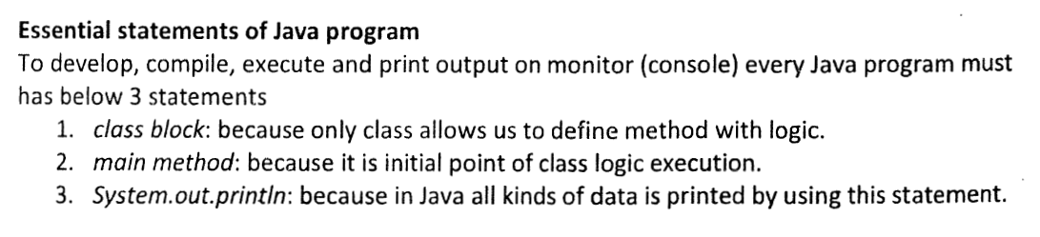

[**Compiling And Running A Java Program**](http://javaconceptoftheday.com/compiling-and-running-java-program/)

***class Hello***

***{***

***public static void main(String args[])***

***{***

***System.out.println("Hello World");***

***}***

***}***

Type the above java program in notepad and save with a class name in the **bin** folder of JDK installation directory like “**Hello.java**“. File name should be same as **class name** and extension should be **.java.**

Open the Command Prompt and go to bin folder of JDK installation directory. (In my system, it is I:\Java\jdk1.7.0_25\bin)  
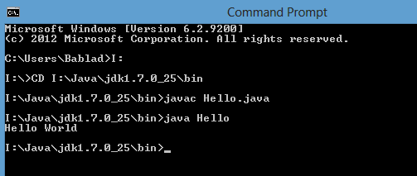  
Use CD command to go to bin folder of JDK installation directory.

**>CD I:\Java\jdk1.7.0_25\bin**

Then trigger **javac** command. **javac command is used to compile any java files.**Pass file name as an argument to the javac command. Don’t forget to add .java extension to the file name like below.

**I:\Java\jdk1.7.0_25\bin>javac Hello.java**

If the java file contains any compile time errors, compilation will be failed and list of errors will be displayed on the console. If  the java file does not contain any compile time errors, compilation will be successful and **.class** file will be generated in the same folder.

Now run this generated **.class** file to get the desired output. **java command is used to run .class files.** Trigger java command, you will get “Hello World” as output. Just pass name of generated .class file as an argument to java command. No need to add extension just like below.

**I:\Java\jdk1.7.0_25\bin>java Hello**

Both javac and java commands are in bin folder of JDK installation directory. We have saved our file in the same folder. It is easy to compile and run java files saved in the same folder as that of javac and java command.

[**Usage of javac command with -d option and java command with -classpath option**](http://javaconceptoftheday.com/javac-command-and-java-command/)

Let us consider following java program.

***class ProgramOne***

***{***

***public static void main(String[] args)***

***{***

***System.out.println("Setting Classpath Environment Variable");***

***}***

***}***

Type the above program in notepad and save it as **“ProgramOne.java”**. I will save it in **I:\Sources** in my system.

Till now, we have seen, when you trigger javac command, **.class** file is generated in the same folder as that of .java file. How to make this .class file should be generated in another folder say **I:\Classes**(in my system)? This can be achieved using **-d option** of javac command.

Open the command prompt and go to the location of .java file using CD command.

**C:\…\….> I:**

**I:\> CD Sources                                                             ——-> (In My System)**

Now trigger the javac command with -d option. Syntax of javac command with -d option is,

**>javac  -d  (Specify the path where to save generated .class files)  FileName.java**

We have already set the path environment variable for the whole system, so no need to set it in the command prompt. If you have not set the path environment variable, go through our previous concept to see how to set path environment variable.

Directly run javac command like below.

**I:\Sources> javac -d  I:\Classes ProgramOne.java**

This will save generated .class file in **I:\Classes.**

If you run java command from this location, you will get an error saying **could not find or load main class**. Because .class file is saved in another folder. To run .class file, you need to go to that location, again using CD command. This will be the time consuming. The easy and best way to run .class files saved in another folder is use  **-classpath** option of java command. Syntax of java command with -classpath option is,

**>java  -classpath  (path of generated .class files)  ClassName**

In our example it looks like,

**I:\Sources> java -classpath I:\Classes ProgramOne**

You can also avoid use of -classpath option each time you run java command by setting the classpath variable by using **set classpath** command.

**I:\Sources> set classpath=I:\Classes**

You can also check whether the classpath has been correctly set or not using **echo** command.

**I:\Sources> echo %classpath%       ——-> It will display the value of classpath variable.**

Now you can run java command without using -classpath option.

**I:\Sources> java ProgramOne**

This is how it looked in my system.

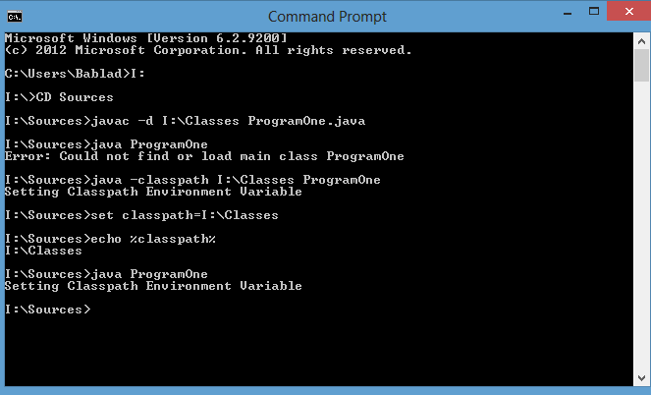

This classpath setting is available only for this instance of command prompt. You can also avoid setting classpath each time you open command prompt by **setting classpath in Environment variables section** of your system. The procedure to set classpath variable is same as that setting path environment variable as we discussed in previous concept.

[Naming, Compiling and Running Java Files Containing More Than One Class Definitions](http://javaconceptoftheday.com/naming-compiling-and-running-java-files-containing-more-than-one-class-definitions/)

Today we will see how to name, compile and running java files containing more than one class definitions.

1). Consider the following program.

***class ClassOne***

***{***

***public static void main(String[] args)***

***{***

***ClassTwo.methodOfClassTwo();***

***}***

***}***

***class ClassTwo***

***{***

***static void methodOfClassTwo()***

***{***

***System.out.println("From Class Two");***

***}***

***}***

**Naming** : You can save this program with any name. It can be **ClassOne.java** or it can be **ClassTwo.java** or it can be **anything.java.**

**Compile** : You have to compile this program with the name you have given like **>javac** **ClassOne.java** or **>javac**ClassTwo.java or >javac anything.java.

When you compile a java file, the number of .class files generated will be equal to number of class definitions in it. i.e If a java file has one class definition, one .class file will be generated. If it has two class definitions, two .class file will be generated and so on.

**Running** : That means for the above program, two .class files will be generated. Then which one to run? is it **>java ClassOne** or is it **>java ClassTwo…..**It must be **>java ClassOne, because execution of any java program start with main() method.** If you try to run **>java ClassTwo,**you will get an **error: Main method not found in class ClassTwo, please define the main method as public static void main(String[] args).**

2). Now consider same example with litte modification, just declare ClassOne as **public**.

***public class ClassOne***

***{***

***public static void main(String[] args)***

***{***

***ClassTwo.methodOfClassTwo();***

***}***

***}***

***class ClassTwo***

***{***

***static void methodOfClassTwo()***

***{***

***System.out.println("From Class Two");***

***}***

***}***

**Naming** : The name of above java file must be and only “ClassOne.java”. You can’t give any other name. If you give any other name you will get compile time error : **class ClassOne is public, should be declared in a file named ClassOne.java.**

**Compile** : Only one name is allowed here so you have to compile with that name i.e **>javac ClassOne.java.**

**Running** : That must be **>java ClassOne.** because this is only class that has main() method.

3). Now make little more modifications to the program. Declare ClassTwo as public and ClassOne as default.

***class ClassOne***

***{***

***public static void main(String[] args)***

***{***

***ClassTwo.methodOfClassTwo();***

***}***

***}***

***public class ClassTwo***

***{***

***static void methodOfClassTwo()***

***{***

***System.out.println("From Class Two");***

***}***

***}***

**Naming** : You have to save this file with name as **“ClassTwo.java”**. If you give any other name you will get compile time error becuase ClassTwo is public.

**Compile** : It must be **>javac ClassTwo.java.**

**Running** : You must name this program as **ClassTwo.java**, you must compile this program as **>javac ClassTwo.java**but you have to run it as **>java ClassOne not as >java ClassTwo.**Because only ClassOne has main() method. ClassTwo doesn’t have main() method. If you run it as **>java ClassTwo,** you will get run time error **:**Main method not found in class ClassTwo, please define the main method as public static void main(String[] args).

4). Now make little more modifications to the program. Declare both the classes as public.

***public class ClassOne***

***{***

***public static void main(String[] args)***

***{***

***ClassTwo.methodOfClassTwo();***

***}***

***}***

***public class ClassTwo***

***{***

***static void methodOfClassTwo()***

***{***

***System.out.println("From Class Two");***

***}***

***}***

**Naming** : Whatever you give the name, whether it is ClassOne.java or ClassTwo.java or anything.java,  you will get compile time error. Because **One java file should contain only one or zero public class. It should not contain more than one public class.**

5) Look at the following program.

***class ClassOne***

***{***

***public static void main(String[] args)***

***{***

***System.out.println("From Class One");***

***}***

***}***

***class ClassTwo***

***{***

***public static void main(String[] args)***

***{***

***System.out.println("From Class Two");***

***}***

***}***

**Naming** : You can save this program with any name. It can be **ClassOne.java** or it can be **ClassTwo.java** or it can be **anything.java** as there is no public class**.**

**Compile** : You have to compile this program with the name you have given i.e **>javac** **ClassOne.java**or**>javac**ClassTwo.java or >javac anything.java.

**Running** : Notice that both the classes have main() method. You can run both the classes with their name. i.e  If you trigger **>java ClassOne**, you will get **From Class One** as output. If you trigger **>java ClassTwo**, you will get **From Class Two**as output.

[**Memory Management In Java – Stack And Heap**](http://javaconceptoftheday.com/memory-management-java/)

Whenever you trigger a java command, it divides allocated memory into two parts – **Stack and Heap.**Stack is used only for execution purpose. Heap is used for storage purpose. consider the following program and we will see how it uses stack and heap memory through diagram.

***class StackAndHeapMemory***

***{***

***static void methodOne()***

***{***

***System.out.println("From Method One");***

***methodTwo();***

***}***

***static void methodTwo()***

***{***

***System.out.println("From Method Two");***

***}***

***public static void main(String[] args)***

***{***

***System.out.println("Main Method Started");***

***methodOne();***

***System.out.println("Main Method Ended");***

***}***

***}***

When you trigger >java StackAndHeapMemory, java command divides allocated memory into two parts. one is stack and another one is heap. As already said, stack is used for execution purpose and heap is used for storage purpose. Here is the steps involved in execution of above program.

**Step 1 :**

First java command enters the stack memory for execution. First it checks whether the class StackAndHeapMemory is loaded in heap memory or not. If it is not loaded, loading operation of class StackAndHeapMemory starts.

**Step 2 :**

Randomly one object is created in the heap memory. It is also called **Class Memory**.  After object creation, all static members are loaded into class memory. You know that execution of every java program start with main() method. So, java commands calls main() method for execution.

**Step 3 :**

main() method enters stack memory for execution. First statement in main() method (Line 16) is executed. It prints “Main Method Started” on the console. In the second statement (Line 17), it calls methodOne() for execution.

**Step 4 :**

methodOne() enters the stack for execution. First statement (Line 5) of methodOne() is executed first. It prints “From Method One” on the console. In the second statement (Line 6), it calls methodTwo() for execution.

**Step 5 :**

methodTwo() enters the stack for execution. In the methodTwo(), there is only one statement (Line 11). This statement is executed. It prints “From Method Two” on the console. There is no other statements in methodTwo(). So, methodTwo() leaves stack memory.

**Step 6 :**

Now, again control comes back to methodOne(). Second statement (Line 6) of methodOne() is already executed in step 4. There are no other statements left in methodOne(). So, methodOne() also leaves stack.

**Step 7 :**

Now, control comes back to main() method. second statement (Line 17) of main() is already executed is in step 3. So, now third statement (Line 18) is executed. It prints “Main Method Ended” on the console. As there are no other statements left in main() method, it also leaves stack after clearing the heap memory.

**Step 8 :**

java command also leaves stack memory and gives back the allocated memory to OS.

Here is the diagrammatic representation of memory allocation of the above program.

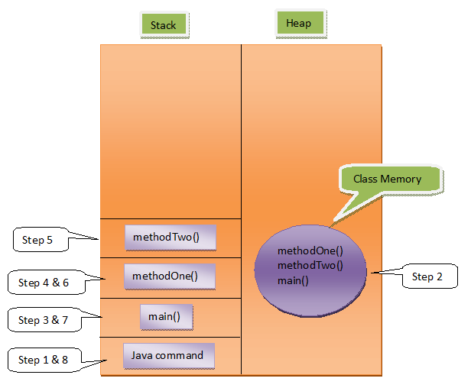

**Output :**

Main Method Started  
From Method One  
From Method Two  
Main Method Ended

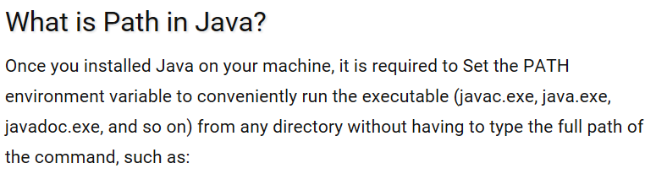

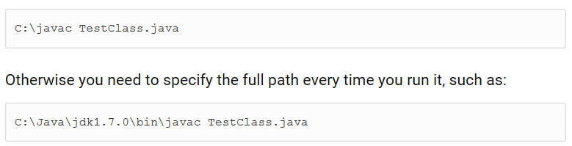 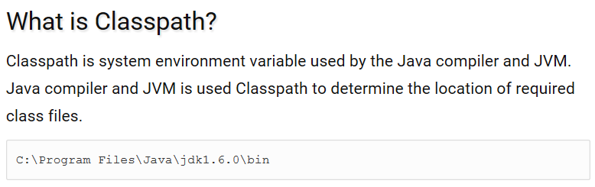 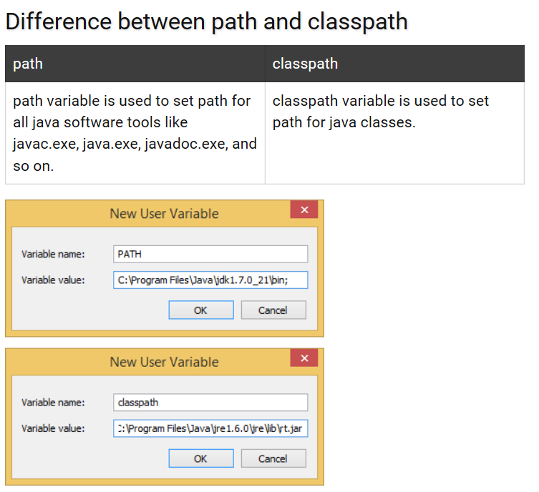 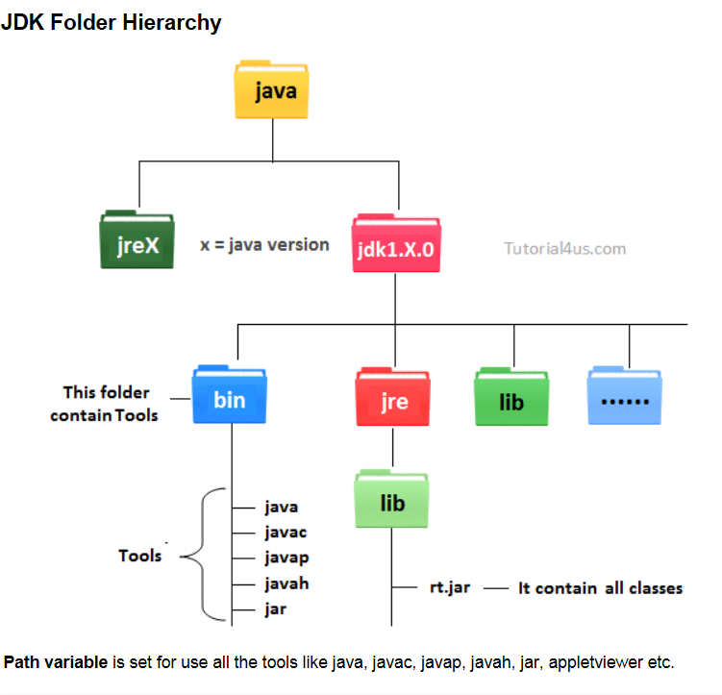

**javadoc - Generating the HTML Output**

1. Create a directory for your Java source code (.java files). In this example, the source code files are inside a directory called groovy, and the source code says that each class belongs to the groovy package.
2. Create a separate directory for your javadoc output (.html files), such as output-groovy.

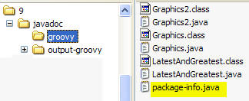

1. Create a package summary file.   
   javadoc requires that it be named package-info.java and that it be in the same directory as your source code files.
2. Put a summary comment about the package in the package summary file.

*/**  
* The groovy package is a set of examples that  
* illustrate the use of javadoc tags.   
* Note: This package summary, like ALL package   
* summaries, must be in a file named   
* <code>package-info.java</code>  
* @version 1.1  
* @author Your Name  
*/  
package groovy;*

1. Navigate one directory **above** the source code directory (from the groovy directory, cd .. at the command prompt).  
     
   D:\__07Fall\9\javadoc>
2. Compile all the classes in the directory,  
     
   javac groovy/*.java
3. Navigate to the directory that contains the source code files.  
     
   cd groovy
4. Run javadoc.  
     
   javadoc *-version -author -d* D:\__07Fall\9\javadoc\output-groovy *.java  
     
   Note: -version and -author tells javadoc to include the version number and author name(s), and -d specifies the directory for the HTML output.  
   So the syntax is:   
       javadoc *option(s)*   directory_for_output    location_of_files_with_javadoc_comments
5. Open the index.html file:  
     
   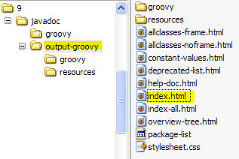

10. Verify that the package summary and author names appear.

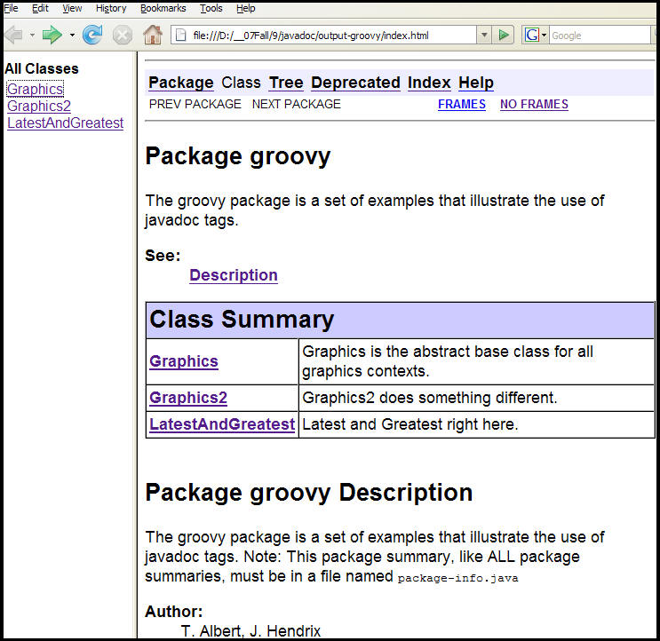

I will run an example where I first cd to

D:\_08summer\javadoc-stuff\zip_of_examples\javadoc

and then give this command

javadoc -version -author -d myOutput groovy\*.java